Rajvi Mehta

  CSU Global

Mis500 Module 4 Critical Thinking Option #1

data TestScores;

input TScore_before TScore_after @@;

datalines;

123 133 135 136 129 135 117 137

120 142 138 135 140 121 145 147

136 168 140 152 146 129 137 145

;

run;

proc print data=TestScores;

run;

ods graphics on;

proc ttest;

paired TScore_before*TScore_after;

run;

ods graphics off;

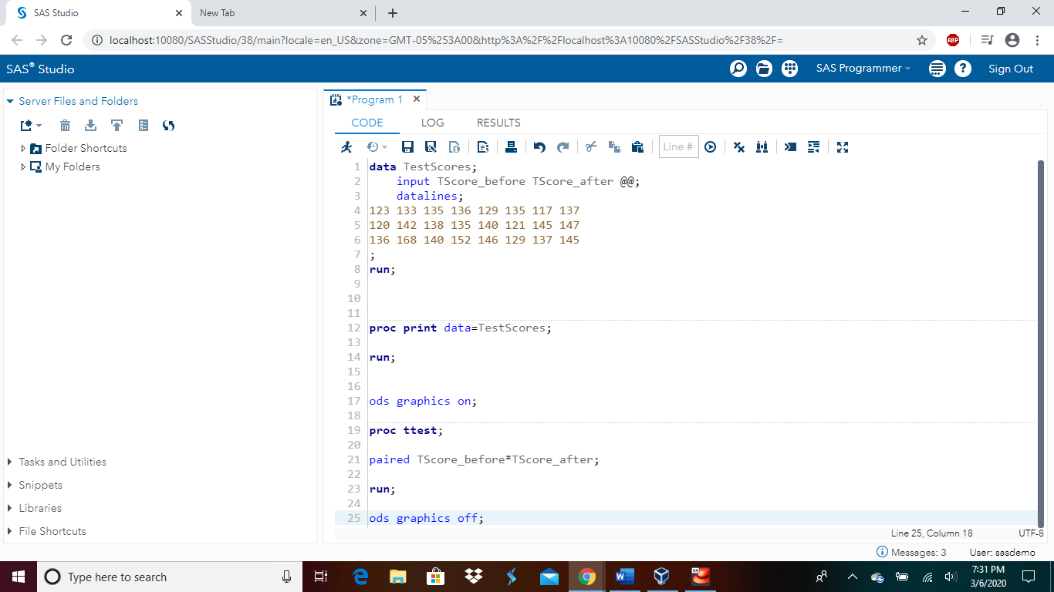

Caption: This screenshot shows the code that is written in the SAS Program.

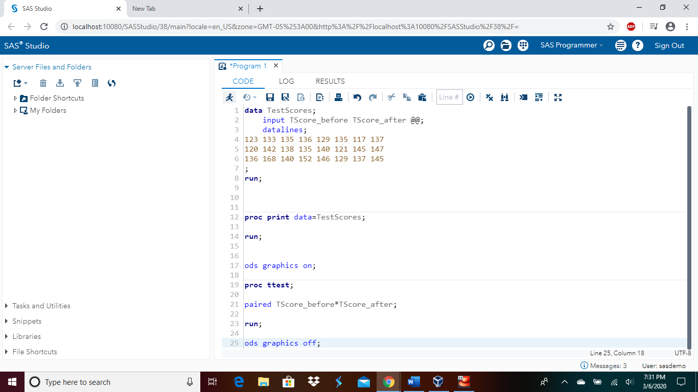

Caption: This screenshot shows the run button highlighted right before this code is executed.

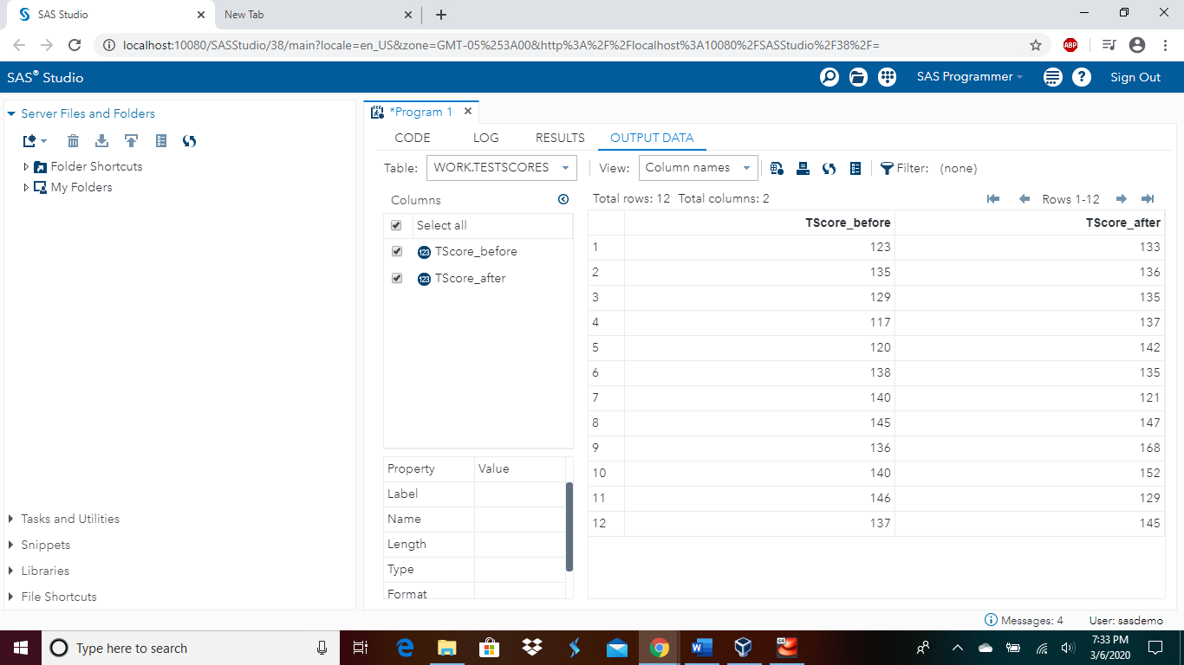

Caption: This screen shot shows the output of the table with the listed numbers.

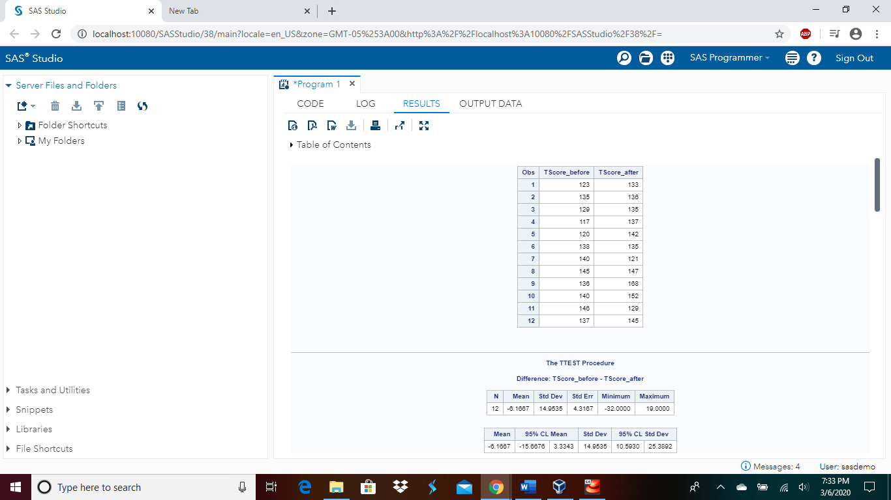

Caption: This screenshot shows the results with the table listed with the numbers.

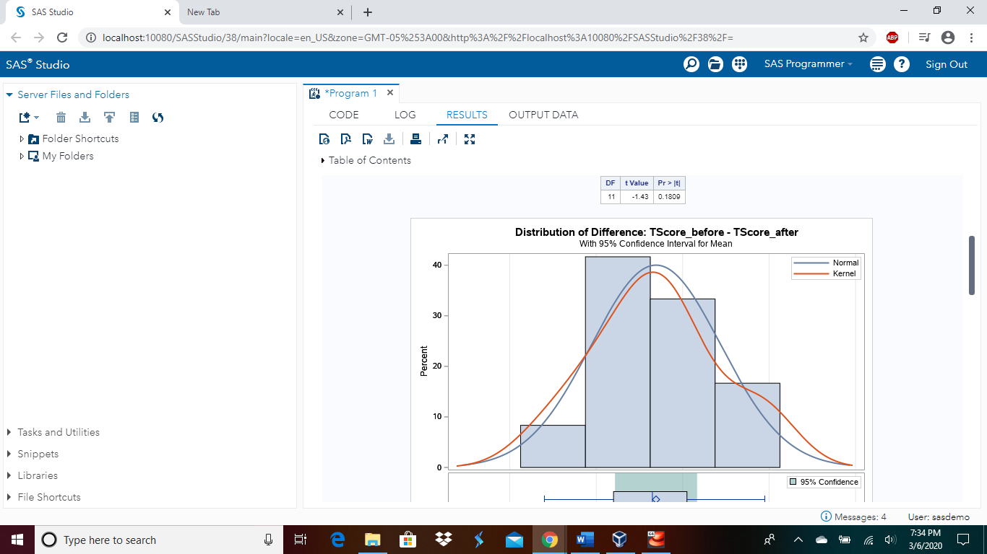

Caption: This screenshot shows the above graph giving a good idea the difference between the two variables.

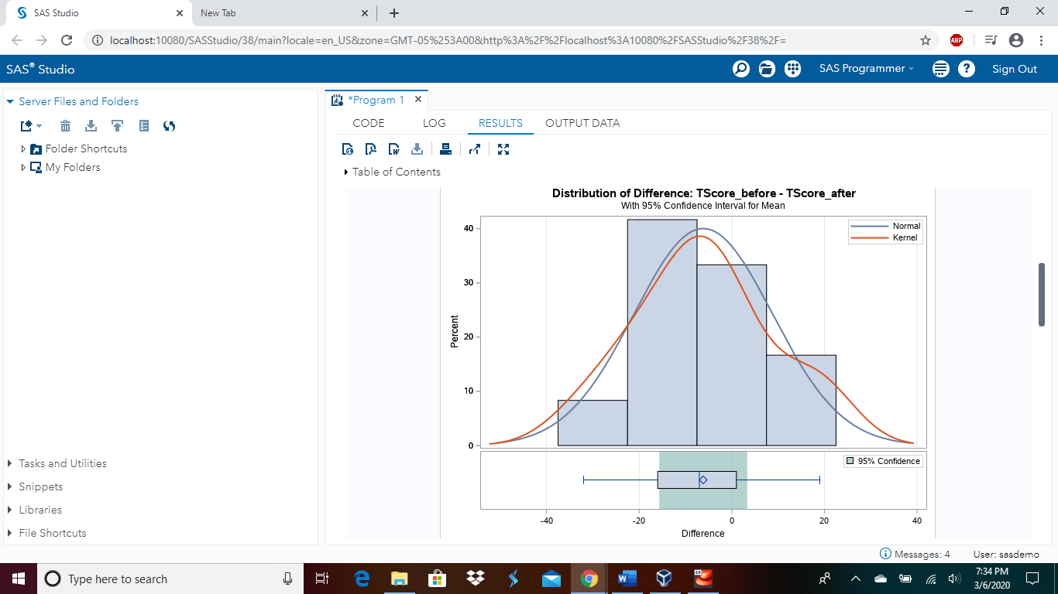

Caption: This screenshot shows the above graph giving a good visual of the difference between the two variables.

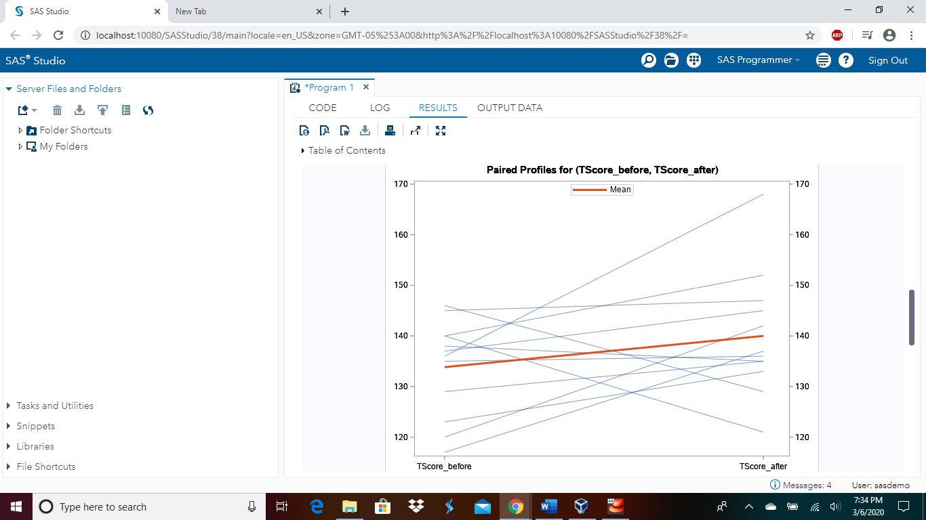

Caption: This specific screenshot shows the above graph of the relationship between the two variables. It shows a positive result.

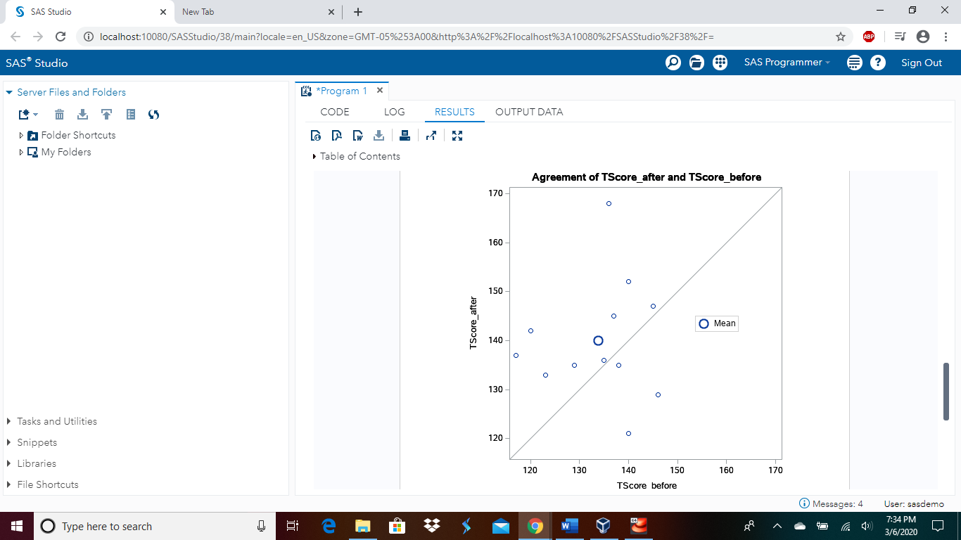

Caption: This screenshot shows the above graph of the relationship between the two variables. It shows a dispersed result.

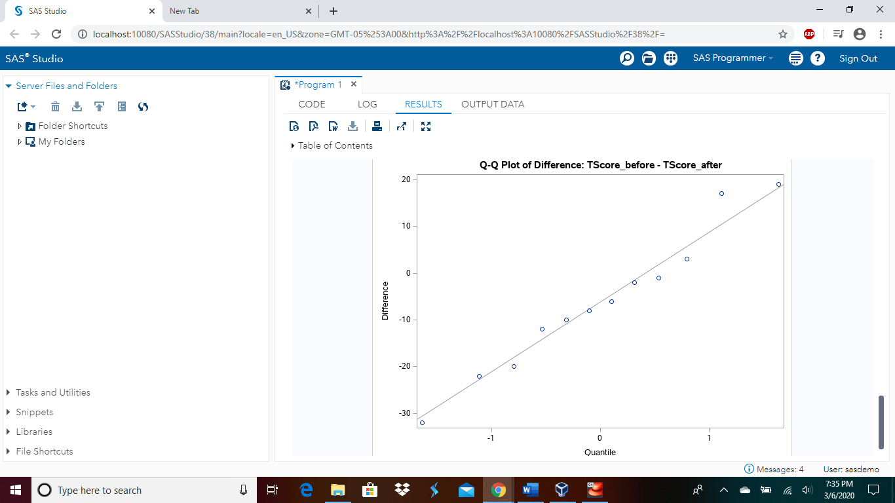

Caption: This screenshot shows the above graph to visualize the relationship between the two variables. It shows a positive result.